**Project Design Phase-II**

**Data Flow Diagram & User Stories**

|  |  |
| --- | --- |
| Date | 29 August 2025 |
| Team ID | LTVIP2025TMID61033 |
| Project Name | Order On The Go |
| Maximum Marks | 4 Marks |

**Data Flow Diagrams:**

A Data Flow Diagram (DFD) is a traditional visual representation of the information flows within a system. A neat and clear DFD can depict the right amount of the system requirement graphically. It shows how data enters and leaves the system, what changes the information, and where data is stored.

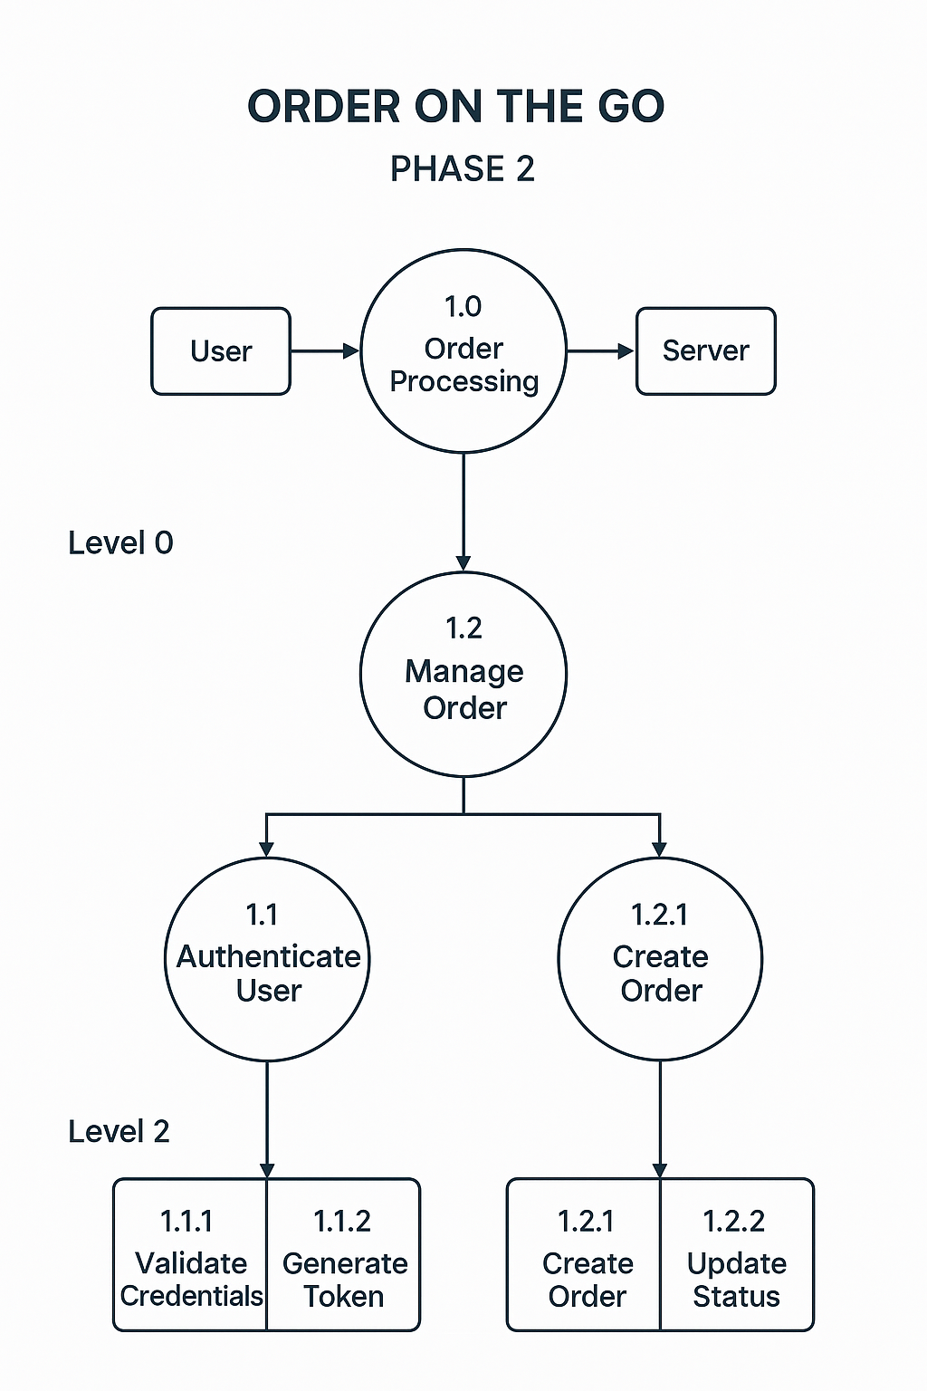

**User Stories**

Use the below template to list all the user stories for the items.

|  |  |  |  |  |  |
| --- | --- | --- | --- | --- | --- |
| **User Story ID** | **Epic / Module** | **User Story (As a… I want… so that…)** | **Priority** | **Acceptance Criteria** | **Task Examples** |
| US-01 | Account Management | As a user, I want to sign up/login quickly so that I can start ordering without delays. | High | User can register/login with email, phone, or social login. | - Build login screen - Integrate social login |
| US-02 | Account Management | As a commuter, I want to save my favourite orders so that I can reorder in one tap. | High | User can save and view past orders; reorder button works. | - Create reorder button - Store favorites in DB |
| US-03 | Menu & Ordering | As a busy parent, I want to use voice ordering so that I can order hands-free. | Medium | App recognizes voice commands and adds items to cart. | - Integrate voice API - Map commands to menu items |
| US-04 | Menu & Ordering | As a traveller, I want to see nearby restaurants so that I can find food easily. | High | Location-based restaurant list shown within 5 seconds. | - Add GPS service - Filter nearby vendors |
| US-05 | Menu & Ordering | As a frequent customer, I want auto-apply loyalty rewards so that I save money. | Medium | Discounts auto-applied at checkout if eligible. | - Add rewards logic - Display applied discounts |
| US-06 | Payment Processing | As a user, I want to store payment methods securely so that I can checkout faster. | High | Multiple payment methods saved securely (PCI compliant). | - Encrypt card details - Integrate wallet APIs |
| US-07 | Payment Processing | As a customer, I want to use rewards/discounts at checkout so that I get best value. | High | Discount applied and visible before confirming payment. | - Validate promo codes - Display final price |
| US-08 | Order Fulfillment | As a user, I want to track my order in real-time so that I know arrival time. | High | Order status updates every minute with map tracking. | - Integrate tracking API - Build status UI |
| US-09 | Order Fulfillment | As a delivery partner, I want optimized routes so that I deliver faster. | Medium | Route suggestion updates when traffic changes. | - Add maps API - Optimize routes |
| US-10 | Notifications | As a user, I want instant order status updates so that I can plan my time. | High | Push notifications triggered at order placed, prepared, en route, delivered. | - Integrate push service - Setup notification events |

